FACT SHEET

Chocolate Nation, world’s largest Belgian Chocolate Museum, is a museum filled with sensory experiences and stories of chocolate brands and chocolatiers. Chocolate traditions, history, products and innovations are brought to life in this experience museum.
In fourteen thematized spaces visitors are taken through a 60 to 90 minute chocolate journey. Starting in the cocoa plantations at the equator and following the cocoa bean to the world’s largest storage port of cocoa in Antwerp. A giant fantasy machine demonstrates how chocolate is made and how the velvety taste is created. Visitors discover why Belgian chocolate is world famous and of course chocolate tasting is included.

Numbers
Surface area:4.000m²
Number of employees: (FTE’s) : 40+ team of 80 Students and flexis
Total investment: € 10 million – Chocolate Nation did not enjoy any kind of subsidy.
Official opening: 27 march 2019
Aantal bezoekers: 600.000
Founders & Managing Partners Mickelle Haest & Jeroen Jespers

Co-investors
Families De Nolf en Claeys, PMV
(Participation Society Flanders)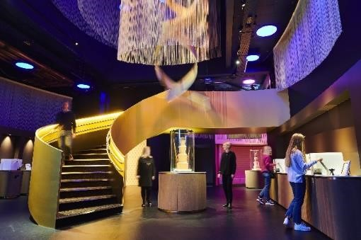

Besides the museum, Chocolate Nation also offers a range of additonal services;
Bar / Restaurant Octave – the world's only bean-to-bar restaurant (13/20 Gault&Millau)
- Chocolate Nation shop with homemade products, various Belgian chocolate brands and chocolate delicacies from well-known local chocolatiers - free access (Finest Belgian Chocolatier guide Gault&Millau)
- Meeting & Event facilities from 20 to 350 guests
- Chocolate Workshops for groups and individuals
- Chocolate Tastings
- Food pairings (chocolate & beer, wine,...)
- Educational programmes for schools
- Professional bean-to-bar
- Audio guides in Dutch, French, English,

Chocolate Nation is located right opposite Antwerp Central Station.

Koningin Astridplein 7 2018 ANTWERPEN
Open all days (including public holidays) from 10.15am to 6.30pm (last tour starts at 5pm).

www.chocolatenation.be
www.chocolatenationshop.be

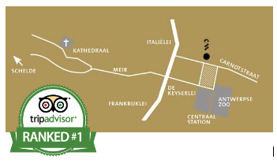
@chocolatenationbe

